

Department of CSE

B.Tech. CSE Trimester -5

2520030176
P. Renuka Chowdary

Cloud Infrastructure and Services
25CS2206E

SKILL 1&2
2026

CREATE IAM USER:

1. Create an IAM user with programmatic access only, download the access key and secret key, and document the steps with screenshots.Then set up a billing alert for the account so that an email is received when the Free Tier limit is about to be crossed.
Description:
IAM (Identity and Access Management) is an AWS service used to manage users and permissions securely. Created a new IAM user and assigned the required permissions. Set an AWS Budget to monitor cloud expenses and control spending. Configured alerts to track budget limits.
STEPS:

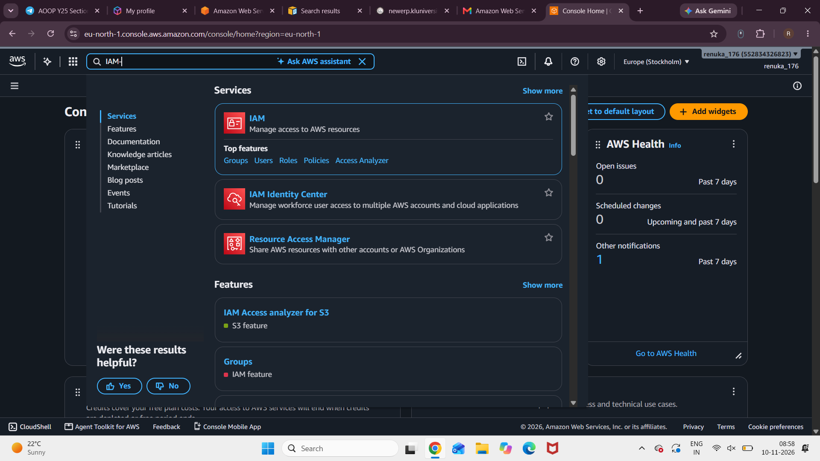
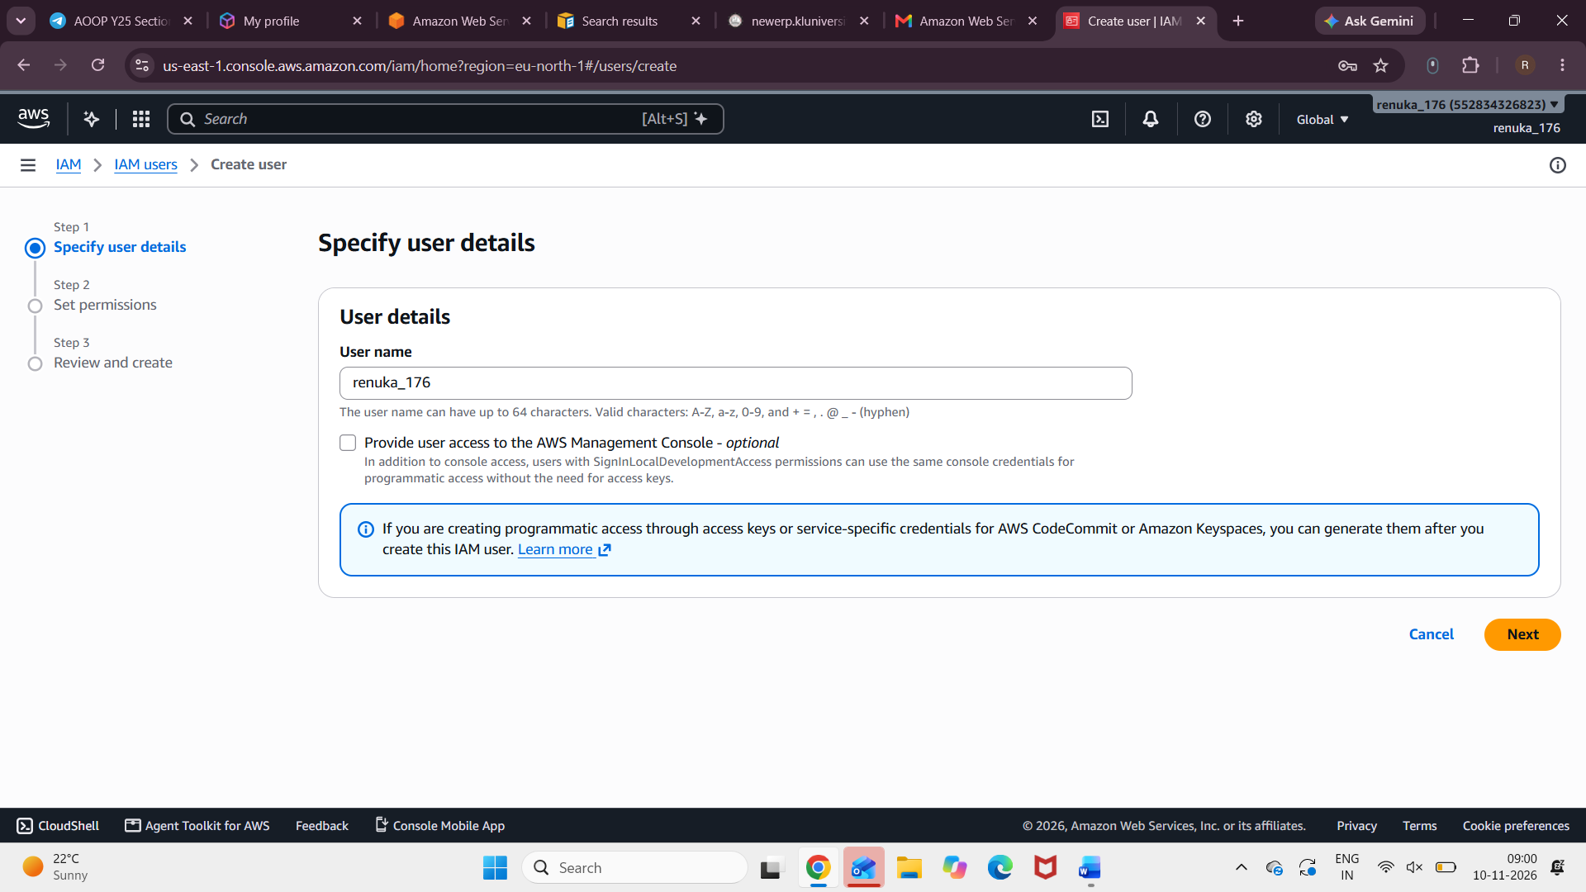
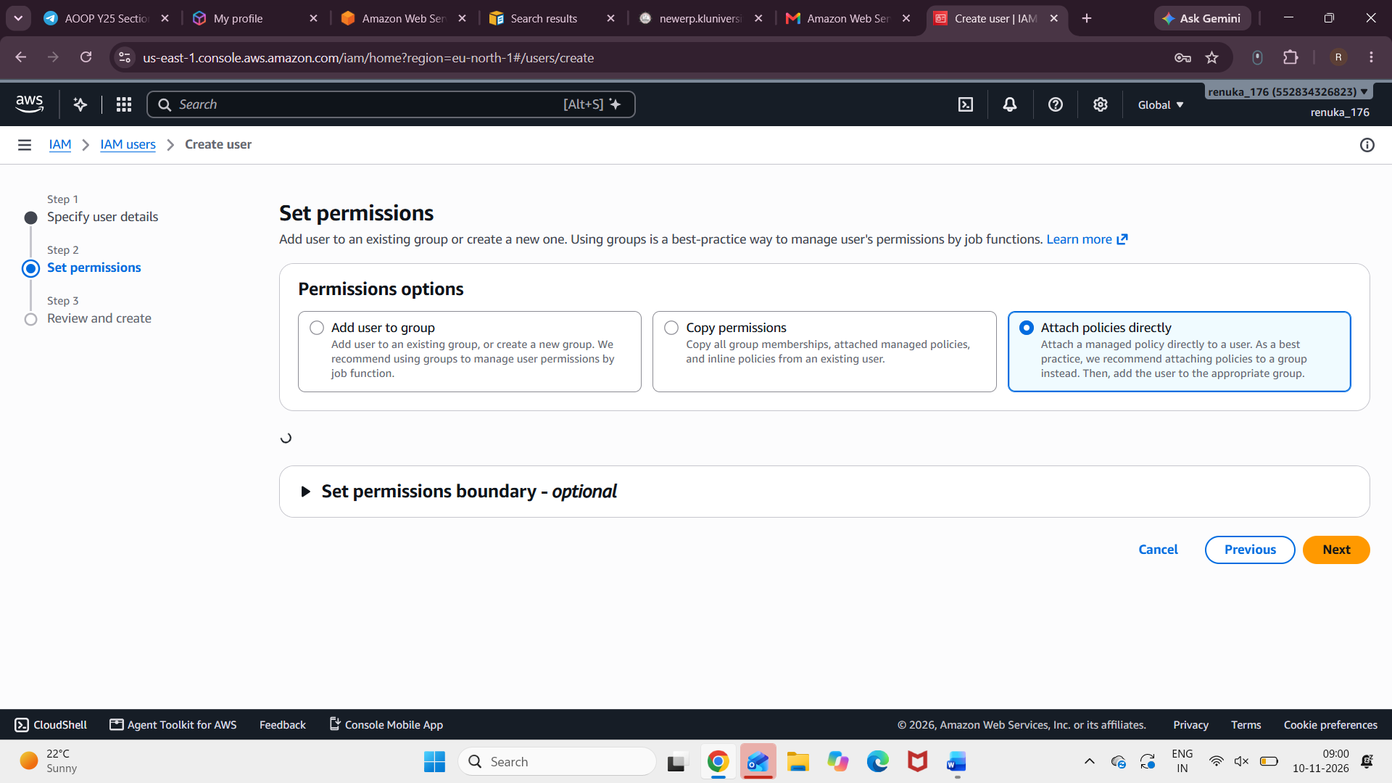
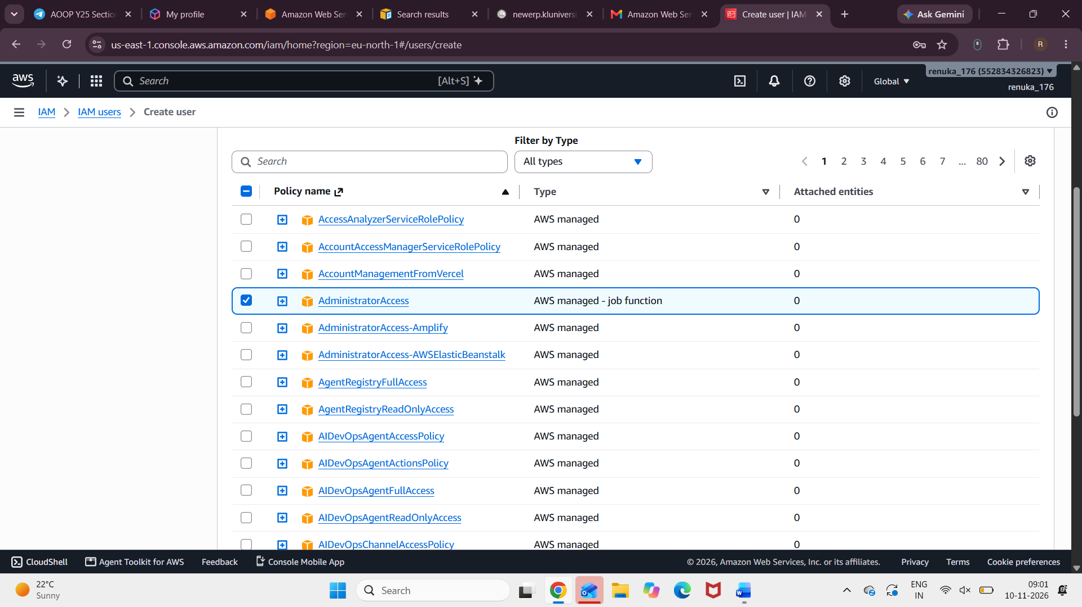
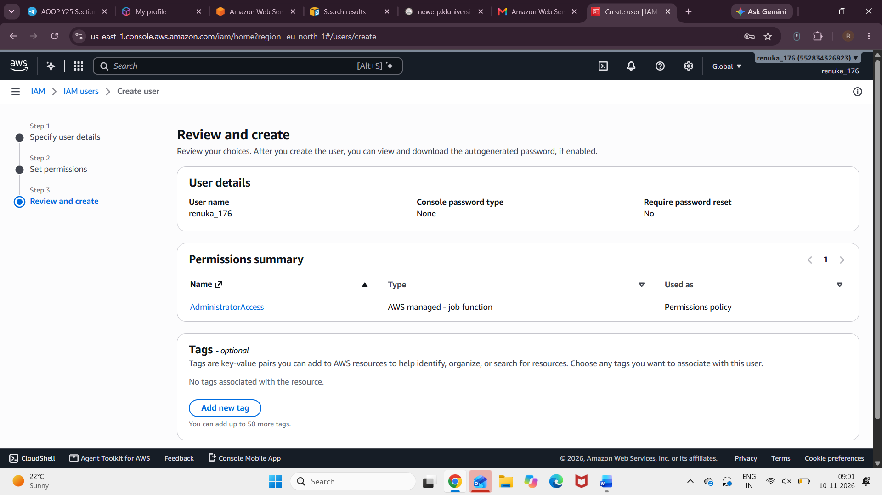
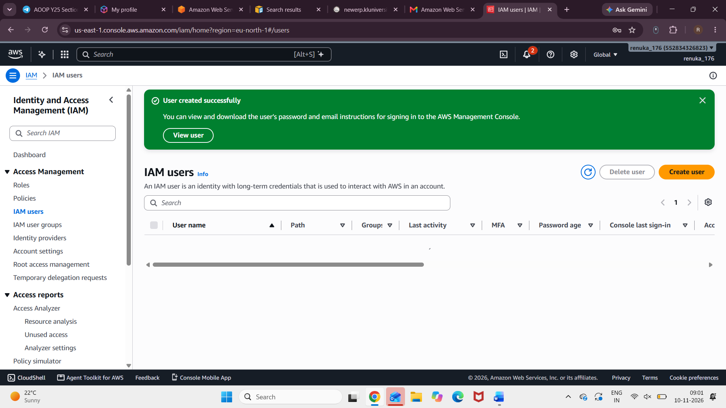
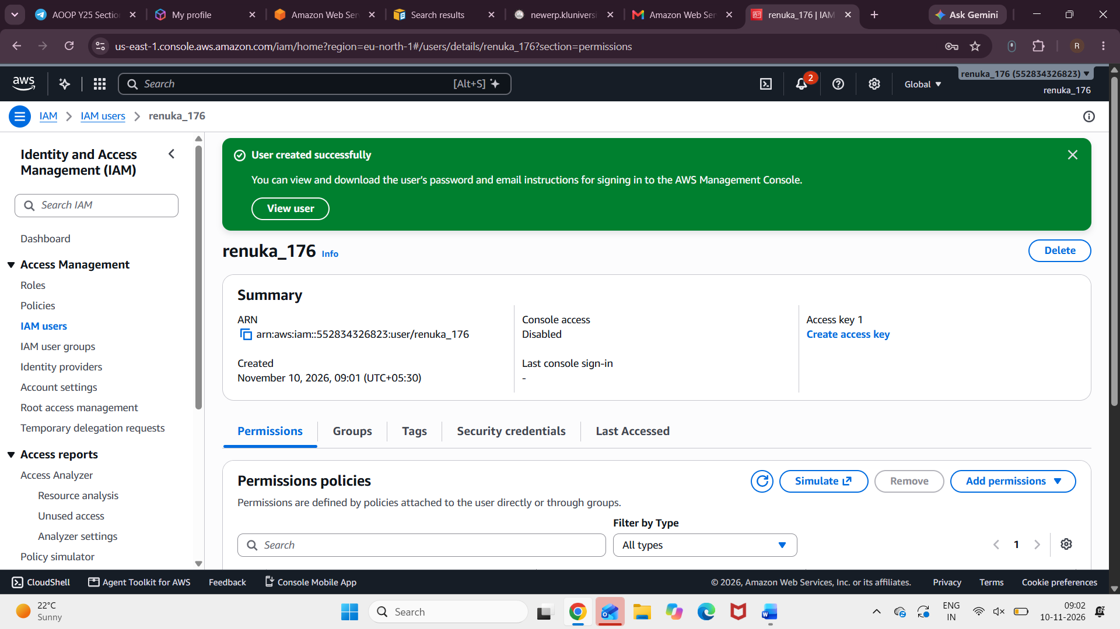
IAM PASS: a%j#hI6)
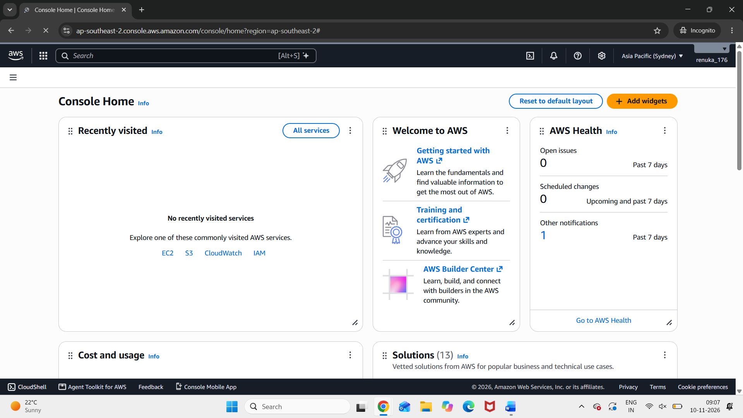
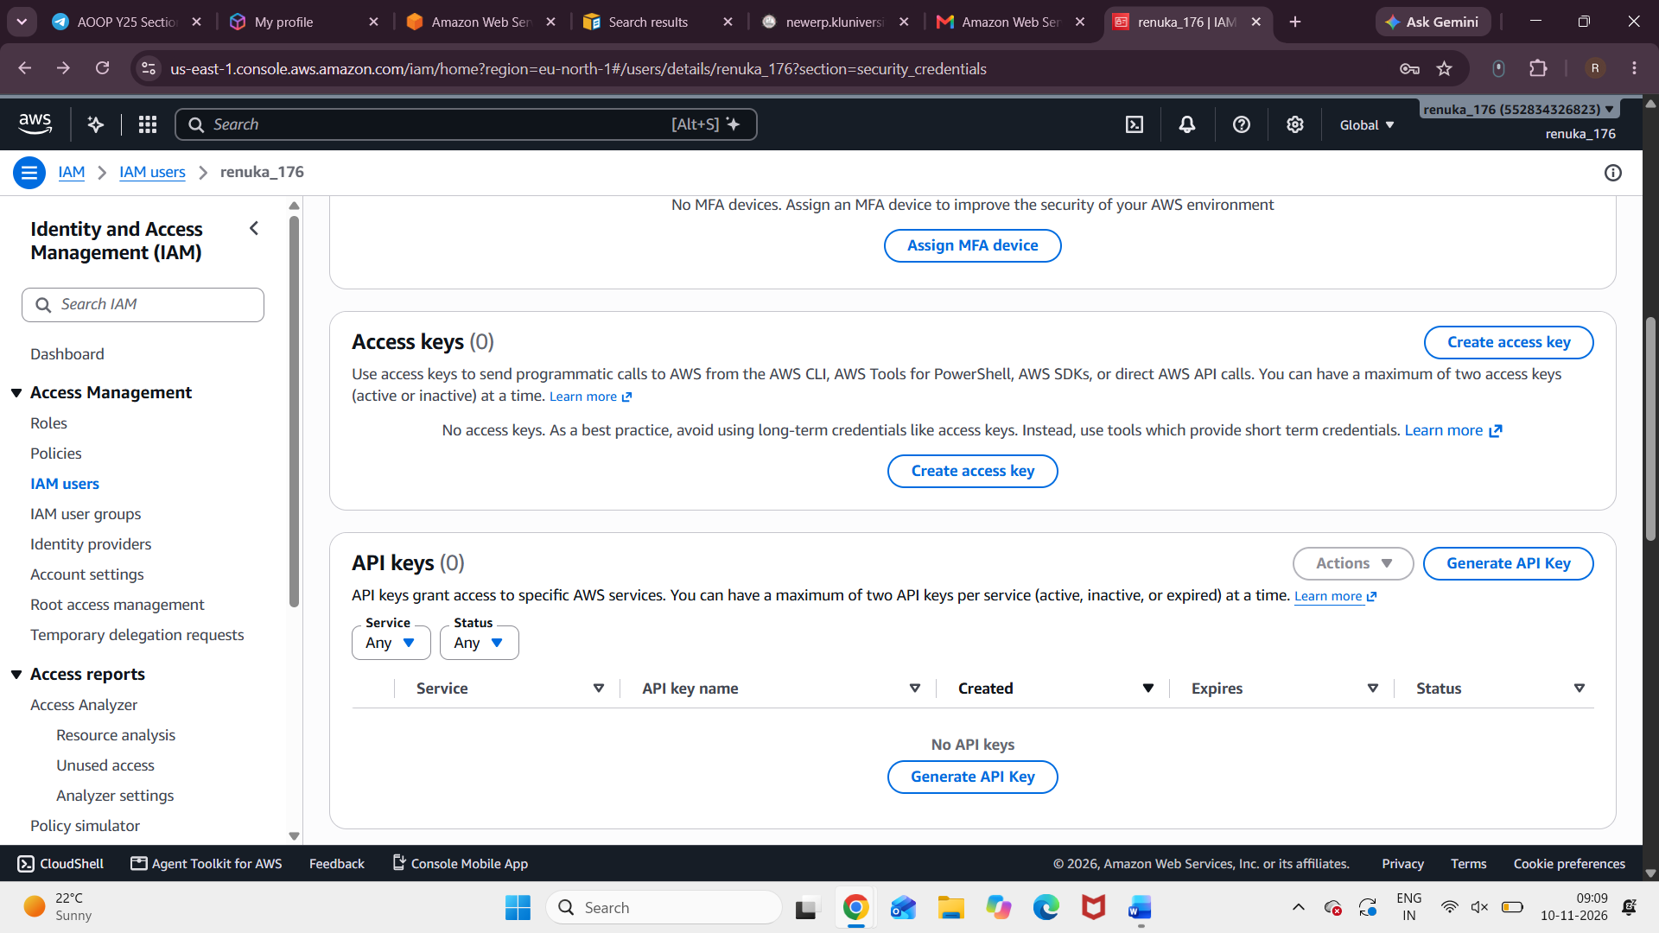

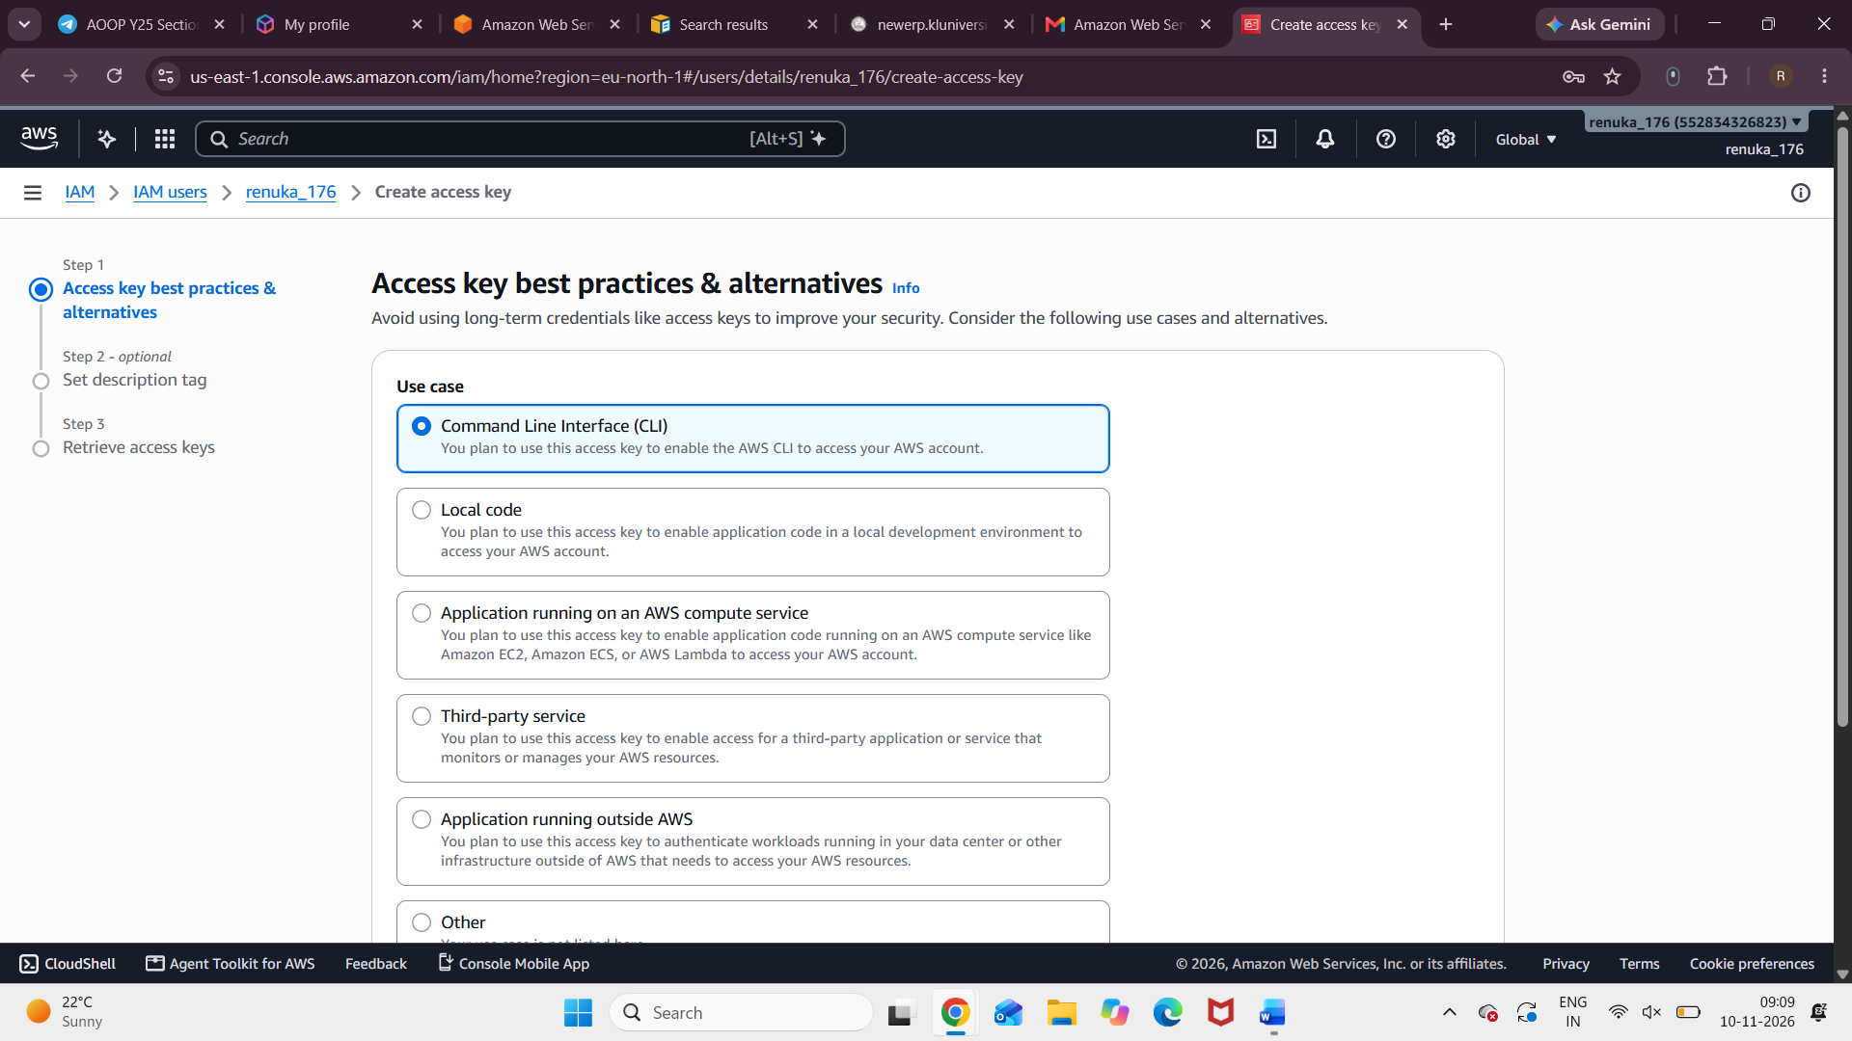
CONSOLE ACCESS KEY: Jg0mlOU8/AYrjIFsTNeYwpZe3ss1I6yafrABjkaq
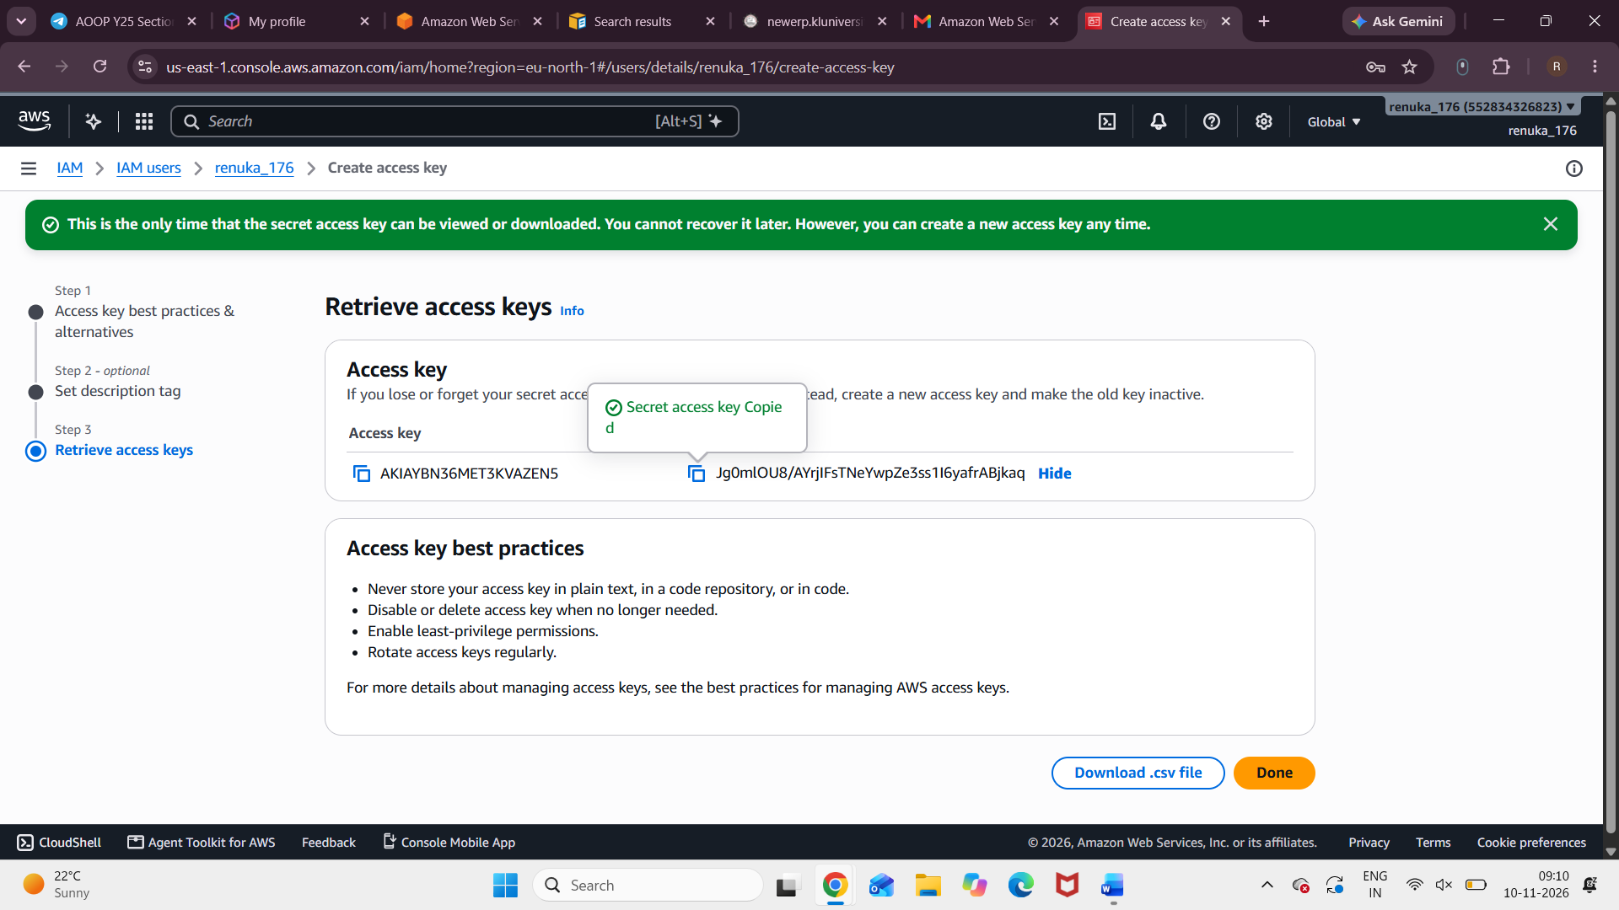
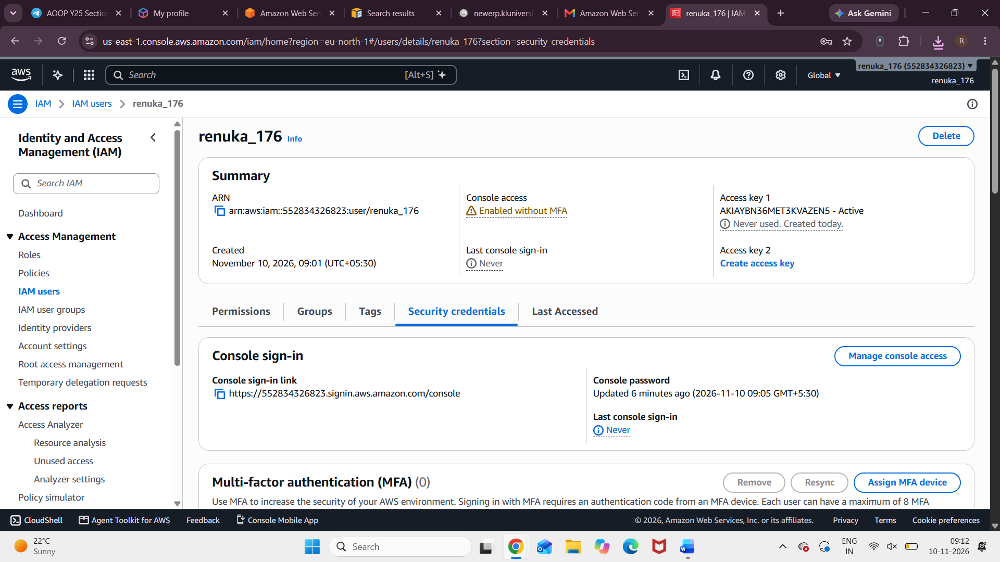
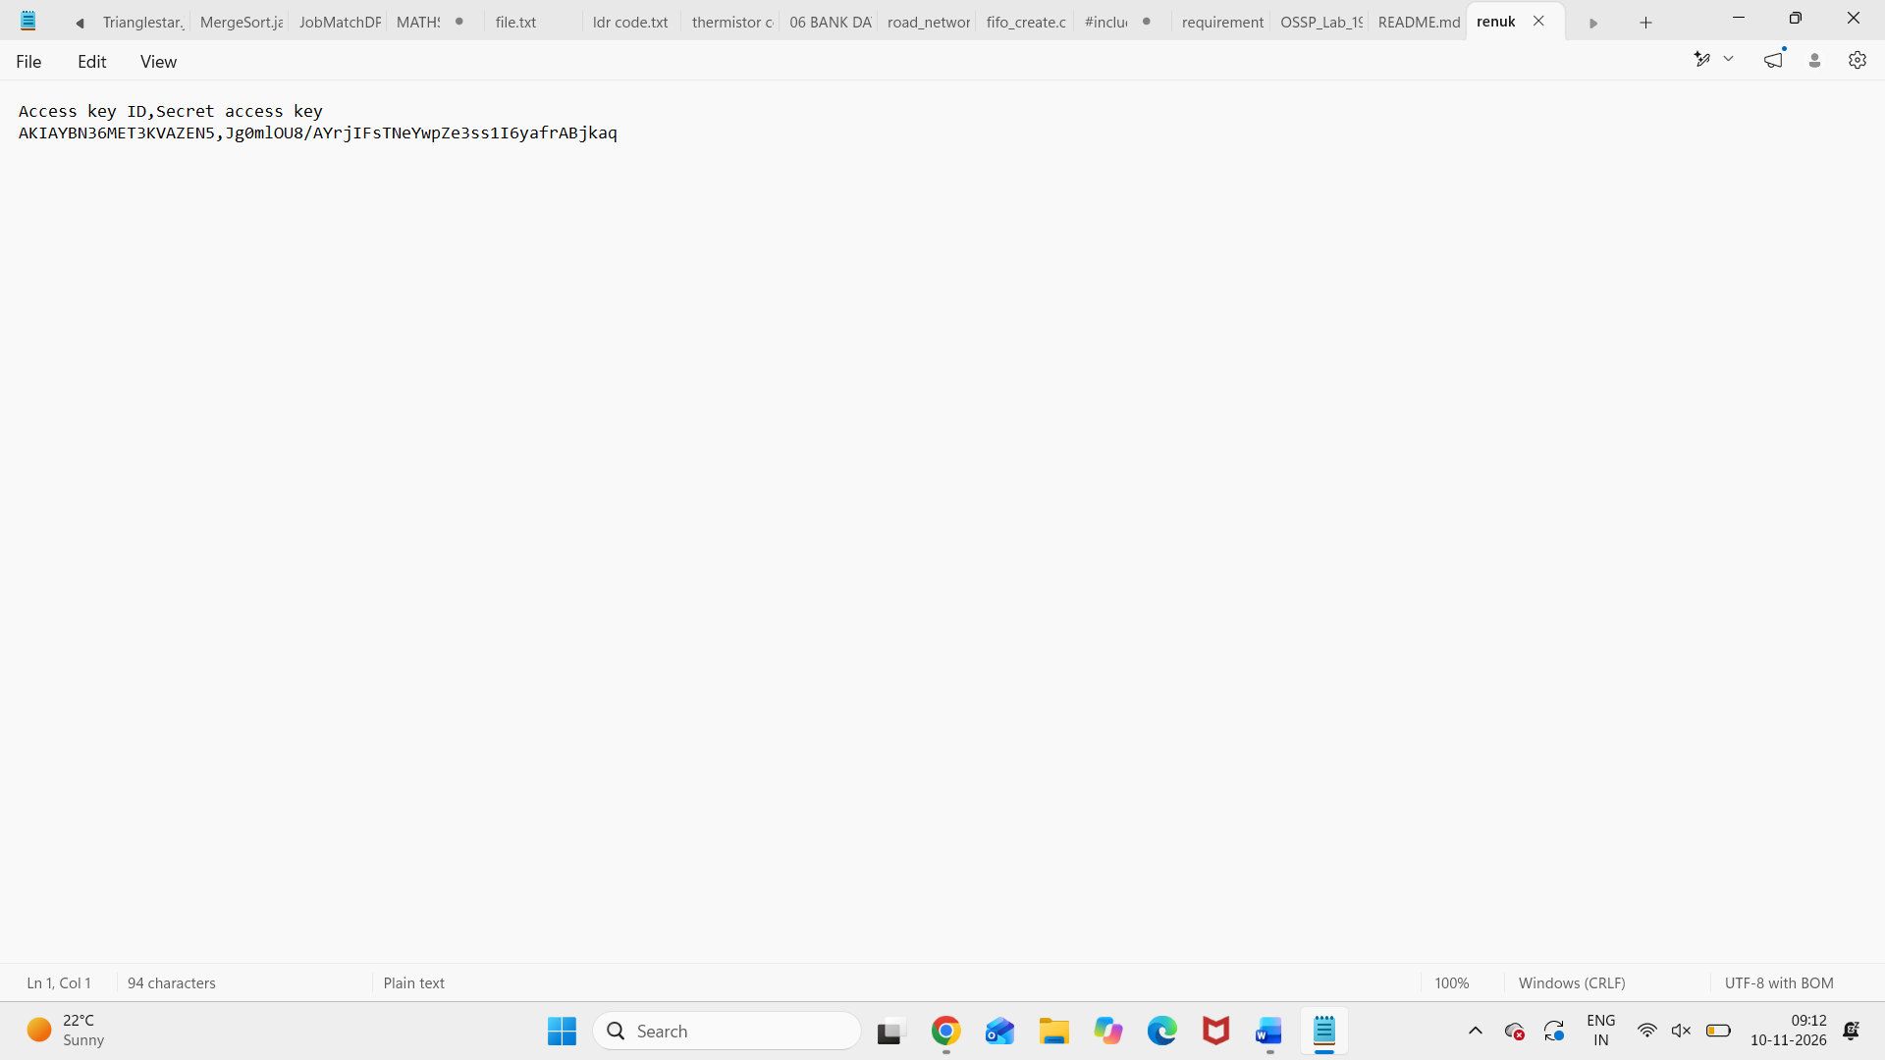
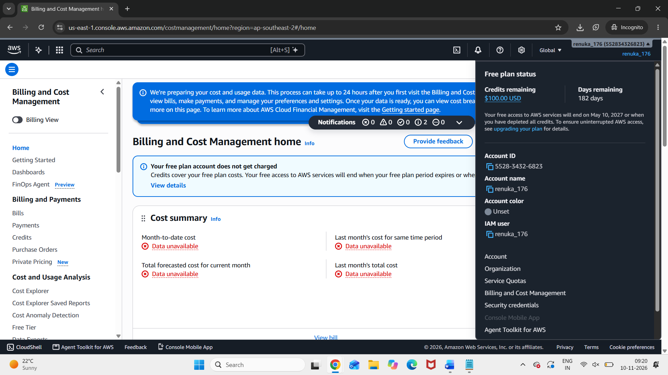
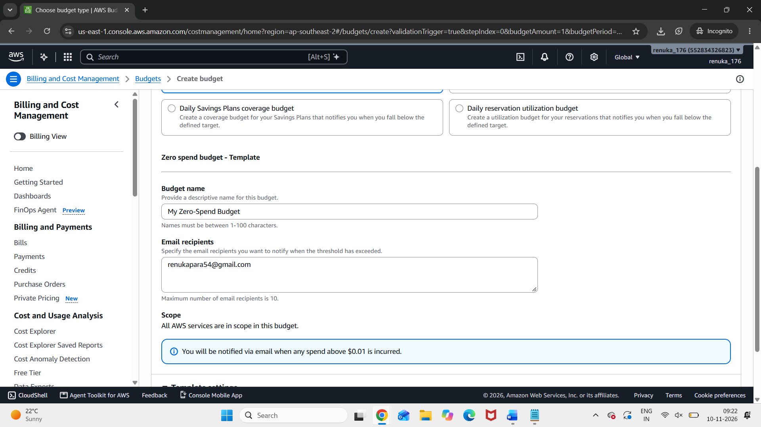
OUTPUT:


